 | Hkkjrh; izksS|ksfxdh laLFkku xqokgkVh  Indian Institute of Technology Guwahati  Guwahati 781 039, India

Chairman, Sports Board

Sl. No. | Name | Period
Sl. No. | Name | From | To
 | Dr. C.Y. Kadolkar, Physics | 1996 | 1999
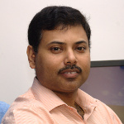 | Dr. P.K. Das, CSE | 1999 | 2001
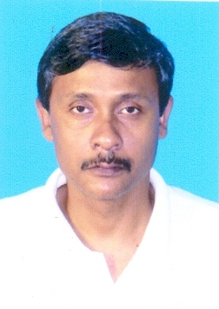 | Dr. A.K. Dass, ME | 2001 | 2002
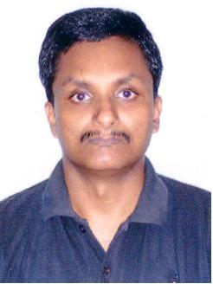 | Dr. D. Chakrabarty, ME | 2002 | 25/7/2005
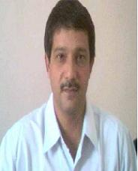 | Dr. Gautam Barua, CE | 26/7/2005 | 18/08/2008
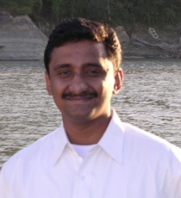 | Dr. P. K. Iyer, Chemistry | 19/8/2008 | 01/01/2012
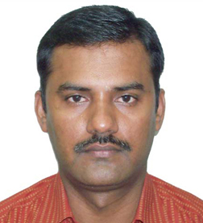 | Dr. Perumal Alagarsamy, Physics | 02/01/2012 | 31/12/2015

